STELLENBOSCH UNIVERSITY

Department of Psychology

UNIVERSITY OF CAPE TOWN

Department of Psychiatry and Mental Health

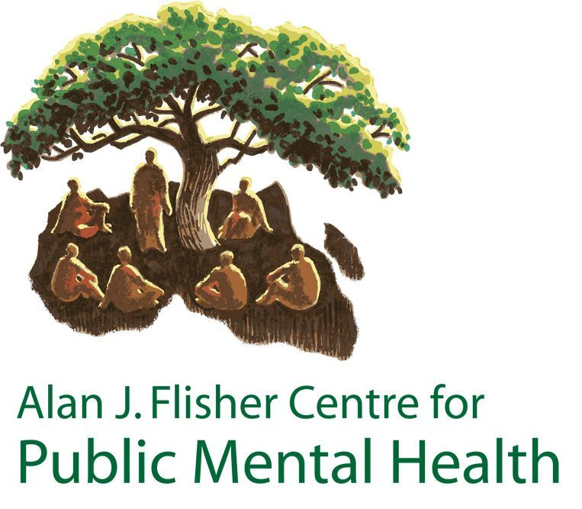

Strengthening public mental health in Africa

CALL FOR APPLICATIONS FOR THE MPHIL IN PUBLIC MENTAL HEALTH FOR 2021
DUE DATE: August 31st, 2020

The Alan J. Flisher Centre for Public Mental Health (CPMH), a joint initiative of the Department of Psychology at Stellenbosch University and the Department of Psychiatry and Mental Health at the University of Cape Town, is an independent inter-disciplinary academic research and teaching centre for public mental health promotion and service development in Africa. The CPMH is proud to invite applications from across the African continent for the Master of Philosophy (MPhil) in Public Mental Health in 2021.

MASTER OF PHILOSOPHY IN PUBLIC MENTAL HEALTH
The MPhil in Public Mental Health is a part-time research degree that aims to develop advanced research skills, enabling participants to undertake their own research projects (such as evaluating services, policies and interventions) as well as interpret research findings for mental health policy and practice. The programme is designed to be accessible to practitioners who work full-time, and who are from a range of backgrounds including social work, psychology, psychiatry, medicine, occupational therapy, nursing, health economics, public mental health, public health, health service management, policy making and non-governmental organisations (NGOs). The training aims to build the professional capacity and leadership of the participants in their work, while contributing to knowledge generation in Africa.
The degree requires:
- The completion of a 3-week residential training module in research methodology for public mental health in Cape Town (depending on COVID-related restrictions, this training may be delivered via an online platform and students will not be expected to travel to Cape Town);
- Participation in an online writing course March 2021;
- Participation in monthly webinars
- The preparation of a dissertation of a minimum of 20 000 words.

3-week Residential Training Module in Research Methodology
The course will start with a 3-week residential training session in Cape Town from 18 January – 5 February 2021. Students will attend lectures, seminars and workshops at the University of Cape Town. The content of the residential training module will be focused on research methodology for public mental health. The training includes an orientation to public mental health, quantitative and qualitative research methods, statistics and epidemiology for mental health, an introduction to systematic reviews, and an introduction to economic evaluation.
During the residential training session students are also expected to meet with their research supervisors and develop their draft research proposals, which they are required to present to a review panel on Friday 5 February 2021.
Following the residential session, participants will be provided with ongoing support and supervision via e-learning, guiding them through the process of finalising their research proposals, gaining ethics approval for the research, gathering and analysing data for their research, and eventually completing their dissertations. During the 2 years that are required to complete the dissertation, students will be required to attend monthly webinars from their home countries, which will be used to provide additional structured teaching and review research progress.

Public Mental Health Dissertation
The dissertation component aims to provide students with the opportunity to acquire specialised knowledge in a specific area of Public Mental Health. It also provides a practical opportunity for the student to master the research process, which includes selection of a topic; self-driven but supervised investigation; data collection and management; assimilation, analysis, interpretation and critical discussion; understanding and coherent presentation. The dissertation will preferably be related to the ongoing work conducted by participants in their respective countries. For example, students may choose to evaluate a mental health programme in their own service organization or region. This would serve the dual function of the development of the student’s research skills and service development, with ongoing support and supervision from the CPMH. Since some data collection activities may be hampered by the ongoing COVID-19 pandemic, students may be advised to consider using secondary data for their research or exploring mental health aspects of the pandemic in their countries.
The dissertation is examined according to the University’s regulations for the examination of master’s theses as stipulated in the relevant university handbook. Dissertations will be assessed by two external examiners, other than the one at which the student is registered and/or international academic institutions.
Research supervisors employed by the Centre are acknowledged experts in public mental health, with a proven publication record and experience of supervising and mentoring students at Masters level.

Registration
Registration is for a minimum of 1 year, and normally the dissertation takes 2 years to complete. For administrative purposes, students will have to register with one of the collaborating universities i.e. with UCT or Stellenbosch. Candidates should indicate their preference on their application, but as we require an equitable number of students enrolled at each university, we cannot guarantee registration at the University of the student’s choice. The course content and requirements will be the same for both universities. The degree will be awarded by the university at which the student is registered.

Admission Requirements
Candidates for this programme should be in possession of an Honours degree, a post-graduate diploma in Public Mental Health or a cognate discipline, or an equivalent four-year qualification. In addition, candidates should:
- have experience of working in a mental health, health or development related field for at least three years;
- be employed within a managerial or leadership role, or have the capacity for such a role;
- have experience in conducting research, with participation in one or more research projects; and
- show evidence of adequate English language and writing proficiency for postgraduate academic studies.

Please Note
- A research programme of this nature requires dedicated time and the ability to work independently. You will require a minimum of 10 hours per week on average to complete the dissertation. Please consider this carefully before applying.
- The MPhil in Public Mental Health does not lead to a professional qualification that can be registered with the Health Professions Council of South Africa or any other health professions council. It is strictly an academic research degree.

Fees
The estimated fees for this course for 2018, at the respective universities, are as follows:
 | UCT | SU
Tuition Fees per year | ZAR 33 910 | ZAR 45 000
International Students Administrative Fee | ZAR 4 000 | ZAR 1 415 (SADC)  ZAR 2 990 (non-SADC)
Application Fee | ZAR 100 (RSA and SADC)  ZAR 300 (rest of world) | ZAR 100
Fees for 2021 will be finalised in October 2020. See information on fees for Stellenbosch University and the University of Cape Town.

Fellowship Opportunities
Although there are no fellowships currently, there may be funded fellowships available for 2021 applicants. If funding becomes available, we will update this webpage with the relevant information. See the UCT postgraduate degree funding noticeboard for other funding options.

Selection Process
Admission to the programme is highly competitive, and is based primarily on academic merit and the potential to contribute to mental health development in under-served areas in Africa. We will engage in a rigorous selection process to identify the candidates who are most likely to successfully complete the degree within the prescribed period. In addition to the written application, short-listed applicants may be requested to attend a teleconference interview.
The deadline for applications is 31 August 2020. The outcome of the selection process will be communicated to all applicants by 31 October 2020.

APPLICATION INSTRUCTIONS
The application forms are detailed, so that we have as much relevant information possible to enable us to select the most suitable candidates. Instructions for completing the application form are provided in this section. Please read and follow these instructions carefully as they are not repeated on the application form itself.
- Download the application forms from the button below.
- The application forms must be completed in full and submitted with all required supporting documents as a single PDF file, with your surname and initial as the file name, to Mobo@uct.ac.za on or before 31 August 2020.
- Each application should consist of the following:

  - Completed application form, including:
    - Photograph
    - Signed declaration
    - Research proposal (see format in the application form)
    - Names of 2 referees. We will contact them directly.
  - Certified copies of original academic transcripts
  - An example of your own academic writing skills such as an article that you have authored. (Please do not submit a co-authored paper as we require an example of your writing skills.)
  - Please do not include any additional material (such as a separate CV) in your application package. Provision has been made on the application form for all information required for the selection process.
- If you have any questions about the application form or process, please contact Songelwa Mobo (Mobo@uct.ac.za).
- Upon selection, students will be given additional information related to their registering university (such as information related to fees, registration, accommodation for the 3 week intensive course, financial assistance, etc), as well as more detailed information about the course.

